## 3. Fly Freifunk Fly!

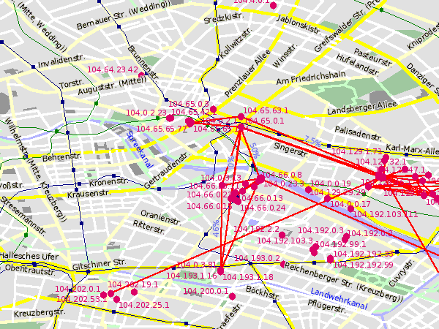Fig. 12. Early Map of Berlin Backbone, courtesy Freifunk.

The Copenhagen Interpolation had induced confidence into the very small number of participants, including a delegation of three from Berlin. In Berlin, the domain freifunk.net was registered in January 2003. The name was coined by Monic Meisel and Ingo Rau over a glass of red wine. Their initial impulse, according to Monic Meisel, was to create a website to spread the idea and make the diverse communities that already existed visible to each other. They wanted a domain name that should be easily understood, a catchy phrase that transported the idea.

Freifunk is a good name. It carries the idea of freedom and the German word *Funk* has more emotional pull than *radio*. *Funk* is funky. The German word *Funke* means spark. The reason is that early radios actually created sparks to make electromagnetic waves. *Funken* thus means both, to create sparks and make a wireless transmission. Meisel, who at the time worked for a German web agency, also created the famous Freifunk Logo and the visual identity of the website.

Fig. 13. Freifunk logo by Monic Meisel. Image courtesy Freifunk.

It seems that Freifunk took off because of a combination of reasons. It quickly found support among activists all over Germany, not just in Berlin. It had people, who had a good understanding of technology and made the right decisions. And Freifunk did very good PR from the start. Jürgen Neumann quickly emerged as a spokesperson for the fledgling movement. However, he could always rely on other people around him to communicate the idea through a range of different means. Freifunk from the start was more like a network of people than Consume has ever been. When James Stevens decided to stop promoting Consume, it ceased to exist as a nationwide UK network of networks.

In spring and summer 2003, the Freifunk germ was sprouting in Berlin. I was writing my German book[1] and started to put draft chapters into the Freifunk Wiki.[2] Freifunk initially grew quickly in Berlin, in particular in areas that had the OPAL problem and thus could not get broadband via ADSL.

In June 2003 the Open Culture conference, curated by Felix Stalder in Vienna, brought together a number of wireless community network enthusiasts. There, Eben Moglen, the lawyer who had helped write the GPL, gave a rousing speech. His notes consisted of a small piece of paper on which he had written:

‘free software – free networks – free hardware.’

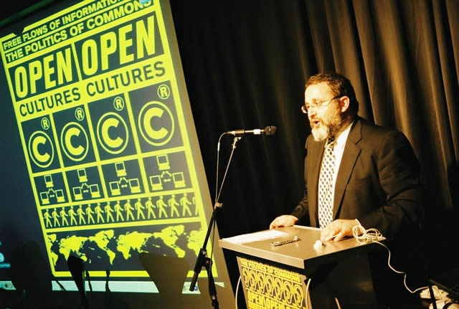Fig. 14. Eben Moglen at OpenCultures conference 2003. Image courtesy t0 / WorldInformation.org.

The holy trinity of freedom of speech and participatory democracy in the early 21st century. His speech was based on the dotCommunist Manifesto[3] which he had published earlier that year. Moglen skillfully paraphrased the communist manifesto by Marx and Engels, writing ‘A Specter is haunting multinational capitalism – the specter of free information. All the powers of *globalism* have entered into an unholy alliance to exorcize this specter: Microsoft and Disney, the World Trade Organization, the United States Congress, and the European Commission.’ Moglen argued that advocates of freedom in the new digital society were inevitably denounced as anarchists and communists, while actually they should be considered role models for a new social model, based on ubiquitous networks and cheap computing power. His political manifesto posited the digital creative workers against those who merely accumulate and hoard the products of their creative labor.

While sharply polemical and as such maybe sometimes a bit black and white in its argumentation, Moglen’s dotCommunist Manifesto is correct insofar as it outlays a social conflict which characterizes our time and is still unresolved. The new cooperative culture of the Net would in principle enable a utopian social project, where people can come together to communicate and create cultural artifacts and new knowledge freely. This world of producers he juxtaposes with another world which is still steeped in the thinking of the past, which clings on to the notion of the production of commodities and which seeks to turn into commodities things that simply are not. This is the world of governments, of corporations and lobbyists who make laws in their own interest which curtail the freedom and creative potential of the Net.

There is no reason why a network should be treated as a commodity. The notion of access to the internet is, as the free network community argues, a false one. The internet is not a thing to which one gets sold access by a corporation. As a network of networks, everybody who connects to it can become part of it. Every receiver of information can also become a producer and sender of information. This is realized on the technical infrastructural layer of the Net, but it has not yet transpired to mainstream society.

### 3.1 Freifunk Summer Convention 2003

In September 2003, the first Freifunk Summer Convention FC03 happened in Berlin at c-base. This self-organized memorable event, from September 12 to 14, brought together a range of people and skills which gave some key impulses to the movement to build the network commons. Among the participants were activists who funded their own travel from Djurslands to join the gathering. This is a district in the north east of Denmark, a rural area with economic and demographic problems. Djurslands.net[4] demonstrated for the first time that you could have a durable large scale outdoor net with a large number of nodes. The guys from Djurslands.net brought a fresh craftsman approach to free networking, with solidly welded *cantennas* (antenna made from empty food can). At the Freifunk convention, it was decided to have the next community network meeting in Djursland in 2004, which turned out to become a major international meeting of community networkers in Europe.

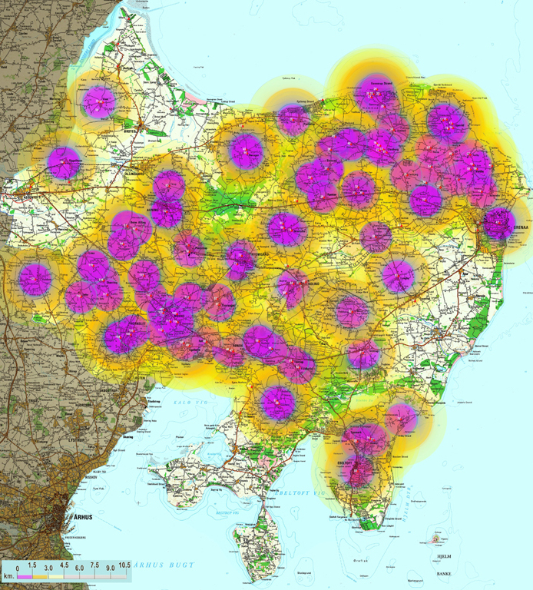Fig. 15. Map of Djurslands.net.

According to conflicting reports at FC03 Bruno Randolf showed the MeshCube, a technology he developed for a company in Hamburg. However, according to a recent entry on the timeline it was only after FC03 that the development of the MeshCube began in serious. At the time, Julian Priest wrote in the Informal Wiki[5]:

Bruno Randolf ran mesh routing workshop. After a good discussion covering the main mesh protocols and solutions, AODV (an early dynamic routing protocol), mobile mesh, scrouter, and meshap, around 10 – 15 linux laptops were pressed into service as mesh nodes using the mobile mesh toolset. Tomas Krag crammed a couple of wireless cards into his laptop (which only just had space to fit) and ran the border router and others stretched the network around the buildings. Many discussions about how to assign IP addresses in the mesh followed, maybe IPv6, mobile IP or Zeroconf could be ways forward here. Bruno demoed the jaw dropping 4G mesh cube. 4 cm cube sporting up to 4 radios, smc type antenna connectors, a 400 Mhz mips 32Mb flash 64M ram, with power over ethernet and usb, currently running Debian. A space to watch for sure.

The MeshCube made use of industrial small chips optimized for running an embedded GNU/Linux distribution. Initially it was configured with the early AODV dynamic routing protocol and later included early versions of the OLSR protocol, developed by Andreas Tønnesen as a master thesis project at the university graduate center in Oslo. However, it seems at FC03, a further dynamic network stack developed by MITRE called ‘Mobile Mesh’[6] was discussed and tested. (See this entry on Mobile Mesh[7], by Elektra, on the early Freifunk Wiki.)

Thus it is confirmed that on a mild day in September 2003 in Berlin, a couple of dozen of geeks could be seen walking around the streets with laptops making, to the ordinary passers-by, incomprehensible remarks about pings and packets. This was the beginning of a long and fruitful engagement of free network communities with mesh routing protocols (see also this report from 2003[8]).

Shortly after FC03, the Förderverein Freie Netzwerke was founded, a not-for-profit organization whose aim was the furthering of wireless community networks. The convention had also mobilized a television crew, who made a short film (in German).[9]

It shows a number of free network advocates including this author at a slightly more youthful age.

As the video makes evident, Freifunk from the start advertised itself as a social project which is about communication and community. Freifunk created an efficient set of tools to be picked up as a kind of community franchise model, as Jürgen Neumann calls it. There is the Freifunk Website with a strong visual identity and the domain name, which also works as an ESSID of the actual networks. Everybody can pick up a Freifunk sub-domain and start a project in a different locality. Freifunk initially grew out of Berlin’s creative new media scene, so that from the very start interesting videos and other new media content was produced.

Another decision that should proof beneficial was that early on Freifunk started to build a Berlin Backbone, long-distance connections between high-rise buildings with reliable radio links. Freifunk was really good at choosing buildings – and getting access to them – with suitable roofs where weather-proof installations could be made. This idea of the Berlin Backbone was a good one from the start, it gave the community something to experiment with. In an interview with radio journalist Thomas Thaler, Sven Wagner advocated the Berlin Backbone as a network linking Berlin’s big alternative culture centers such as ‘Tacheles, CCCB, Bootlab, Lehrter Kulturfabrik, and c-base and a few other projects’.[10]

I believe that for those early long distance connections MeshCubes were used. Those links however, did not mesh, as they were set up on fixed routes. But from those points then bandwidth was redistributed. Thus, from early on a Berlin Backbone grew, such as shown in this image which appears to be from July 2003. (Meanwhile, Berlin Backbone receives financial support from the regional government – more about that in a future installment of this story).

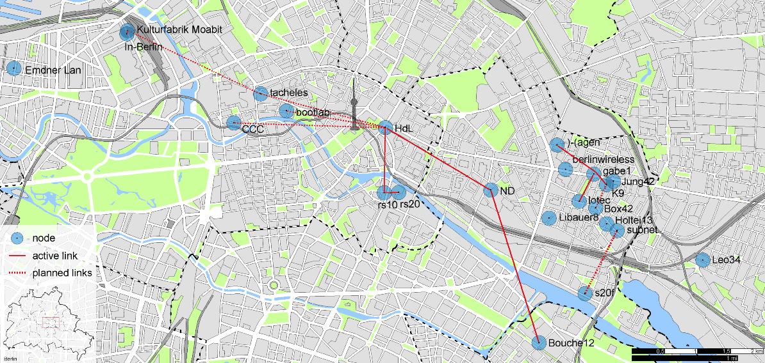Fig. 16. Berlin Backbone, Summer 2003.

In London, if you look at an early map of East End Net, the dots are there but they are not connected. Between Cremer street and Free2air.org and Limehouse there was never a connection. This has partly to do with the urban topology of London, partly with the social structure. Everyone is much more commercially minded, even the church.

In May 2002, there was a Consume workshop in Limehouse Town Hall, where networkers discovered the spire of the adjacent church as an ideal antenna mounting point for a long distance connection. The Vicar, however, had already sold access to the spire of his church to a mobile telephone company.

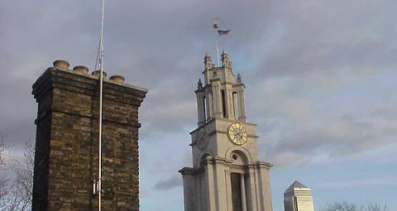Fig. 17. An omni-directional antenna by Consume, a spire and the towers of the financial center, East London, 2002.

It seems significant that today’s Berlin Backbone uses quite a few churches. Another aspect of the social side is that in Berlin it is easier to find people who have time to engage in voluntary labor. The combination of lower costs of living and the remainder of a welfare state make it easier for socially motivated techies to devote unpaid labor time to such projects. In London, that capitalist behemoth, everybody is under permanent pressure to make money, unless one is very privileged or young enough to live in insecure squats. Such comparisons, however, should not make us conduct false comparisons. At around 2003-04, Consume was still very innovative and dynamical, while Freifunk was also developing rapidly.

If we follow this list of links from the Wayback Machine,[11] then we can see that in autumn 2003 there were already quite many initiatives. The timeline which has recently begun as a cooperative work, shows similar results.[12]

In spring 2003 also the early beginnings of Funkfeuer in Austria were made. Funkfeuer, which means radio beacon, was initially built by the artist Franz Xaver for Silverserver. When the provider decided that this was commercially not viable, the network was taken over by a group of volunteers, among whom was Aaron Kaplan. He had already, together with Austrian digital civil rights initiative Quintessenz, made an open WLAN hotspot in Vienna’s Museum District (Museumsquartier). Funkfeuer has since successfully branched out to Graz and a number of rural locations.

In above mentioned interview, Elektra also made a strong statement in support of meshing technology, expressing confidence that the Free Software community would solve this. The confidence should proof to have been justified. In autumn 2003 Elektra spoke about joining together a GNU/Linux distribution such as Knoppix with everything a wireless community node should be capable of, especially meshing. The protocol under deliberation was still mobile mesh, but this would change soon.

1. Armin Medosch, Freie Netze. Geschichte, Politik und Kultur offener WLAN-Netze, Heise Verlag, Hannover 2004, https://ftp.heise.de/tp/buch_11.pdf.
2. Manuscript of Armin Medosch, Freie Netze in the Freifunk Wiki, archived March 2004, https://web.archive.org/web/20040301060127/http://www.freifunk.net/wiki/FreieNetze.
3. Eben Moglen, dotCommunist Manifesto, January 2003, https://moglen.law.columbia.edu/publications/dcm.html.
4. Djurslands.net, archived January 2014, https://web.archive.org/web/20140102104641/djurslands.net/.
5. Freifunk Report on the Freifunk Summer Convention, Informal Wiki, Last edited on 19 September 2003, archived December 2003, https://web.archive.org/web/20031207152025/http://informal.org.uk/wiki/index.php/FreifunkReview.
6. MITRE Corporation, Providing Solutions For Mobile Adhoc Networking, last update 8 October 2003, archived February 2004, https://web.archive.org/web/20040202044948/http://www.mitre.org/work/tech_transfer/mobilemesh/index.html.
7. Elektra, Mobile Mesh, Freifunk Wiki, archived March 2004, https://web.archive.org/web/20040313124958/http://freifunk.net/wiki/MeshingUndMeshAPs.
8. Martin Röll, live from freifunk.net summer convention, Das E-Business Weblog, 13 September 2003, archived October 2006, https://web.archive.org/web/20061003173018/http://www.roell.net/weblog/archiv/2003/09/13/live_from_freifunknet_summer_convention.shtml.
9. On Polylux, a TV show (1997–2008) by Tita von Hardenberg broadcast on RBB that unfortunately we could not locate in any archive.
10. Thomas Thaler, ORF Matrix 19 November 2003, transcript, archived December 2003, https://web.archive.org/web/20031205010408/http://freifunk.net/artikel/magazin/0000_BBB_Thomas_Thaler.
11. Frontpage Freifunk Wiki, archived July 2003, https://web.archive.org/web/20030723203256/http://freifunk.net/wiki/FrontPage.
12. Timeline Freifunk in a Freifunk EtherPad, still live today, http://pad.freifunk.net/p/ff-timeline.